Movie Reviews Database

By: Patrick Larmon, Kyle Gould

1. Unzip the file named ‘MovieReviewWebService.zip’
2. Open the folder and double click on the file ‘WebApplication2.sln’ at the bottom to open the project in visual studio
3. Drag the file ‘MovieReviewDB.sql’ into visual studio from the project folder and run to create the whole database, this includes:
   1. Tables
      1. tblDirectors
      2. tblMovies
      3. tblPosts
      4. tblUsers
      5. Includes data for all the tables
   2. Stored Procedures
      1. spAvgCriticScore
      2. spAvgUserScore
      3. spAvgScore
      4. spGetUserPosts
      5. spGetDirectorFilms
      6. spGetUserDeletedPosts
      7. spGetUsersWhoHaveNotPosted
      8. spGetDirectors

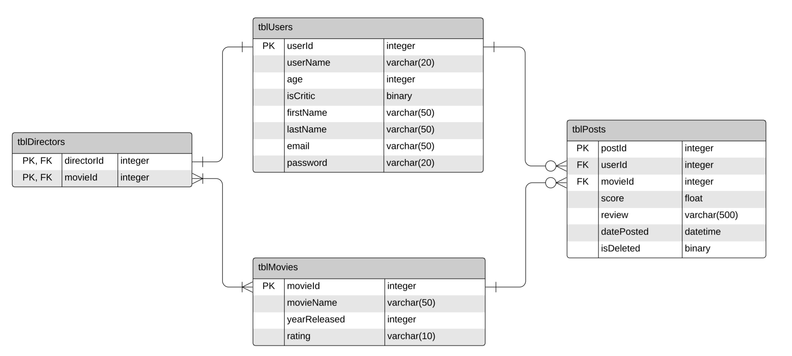

1. Click on the file ‘index.html’ in the solution explorer and then run the program in Google Chrome.
2. The page will display a text box that says ‘User Name’ and prompts you to enter a username to search for posts made by that user. Valid user names include:
   1. Bobby52
   2. Skull67
   3. SunSidney
   4. Budy_Paco
   5. SimpsonLover
   6. FrzAnna
   7. Buckman
   8. Knives27
   9. TheKing
3. By entering a username it will list that users username again as well as all of the postId’s for the posts that the user has made
   1. If an invalid username is put in nothing will come up.
4. The rest of the stored Procedures are present in the database in the stored Procedures folder in Programmability